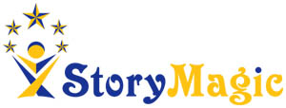
Order Form

Antibullying Show - Oh No It Isn’t! Oh Yes It Is! Digital Version

Name and full address of School

Name of Contact
Email Address of Contact
Phone Number of contact
Price | £100 to include a digital version of the show and workshop (available for November only) and printable resources
 | By placing this order you agree to ensure the content is not shared with any other school.
Signature
Once this order form is received you will receive an invoice. Once this is paid you will receive your resources and details of how to access the digital content. Please check you can access the content a few days before it is intended to be watched in class.

