StoryMagic Logo Print Artwork

Oh No It Isn’t, Oh Yes It Is!

Below is a series of letters from characters that the children met in the show today. The letters are designed to address different issues-

How to play nicely.

(Toby the Dog’s letter)

What to do if you are a witness to bullying

(Judy Juniors Letter)

What to do once you are aware of the bullying

(Professor Cartwright’s letter)

The letters are designed to be spring boards for group or whole class discussions facilitated by an adult. Perhaps the children’s responses could be used to create a “child speak” school Anti Bullying policy. Feel free to expand on them by creating other letters as fits your circumstances or following up with Hot Seating or other drama/art activities.

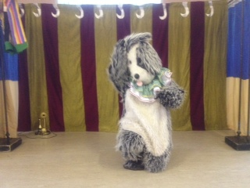

Toby The Dog

Punch and Judy Booth

The Beach

Dear Children

Today I tried to make a new friend but it all went wrong. We were playing a game, I was having lots of fun but then my new friend got all upset and told me I was a horrid dog.

Can you tell me what went wrong?

Thank you

Toby The Dog

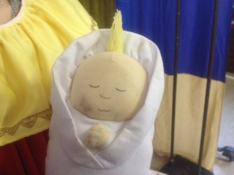

Judy Junior

Punch and Judy Booth

The Beach

Dear Children

I am very upset and don’t know what to do. My mummy, who I like a lot and is nice to me, keeps being horrible to people. She won’t let me play with other people and sometimes makes them sad.

I like my mummy but don’t want her to be horrible to anyone anymore. What should I do?

Thank You

Judy Junior

[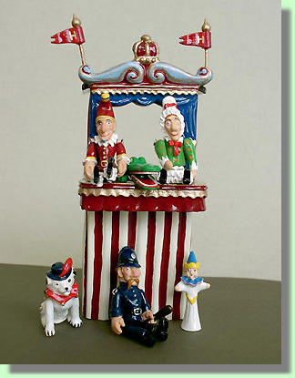](http://www.the-magpies-nest.co.uk/img84.html) Professor Cartwright

Punch and Judy Booth

The Beach

Dear Children

Today I had some bad news. It turns out Judy has been bullying Mr Punch and making him feel very sad. He did the right thing by telling me what has happened.

I feel cross with Judy for being so horrible but don’t know why she did it.

Also I want Mr Punch to feel safe in my Punch and Judy booth again.

What can I do to make everyone be friends and feel happy again?

Thank You

Professor Cartwright