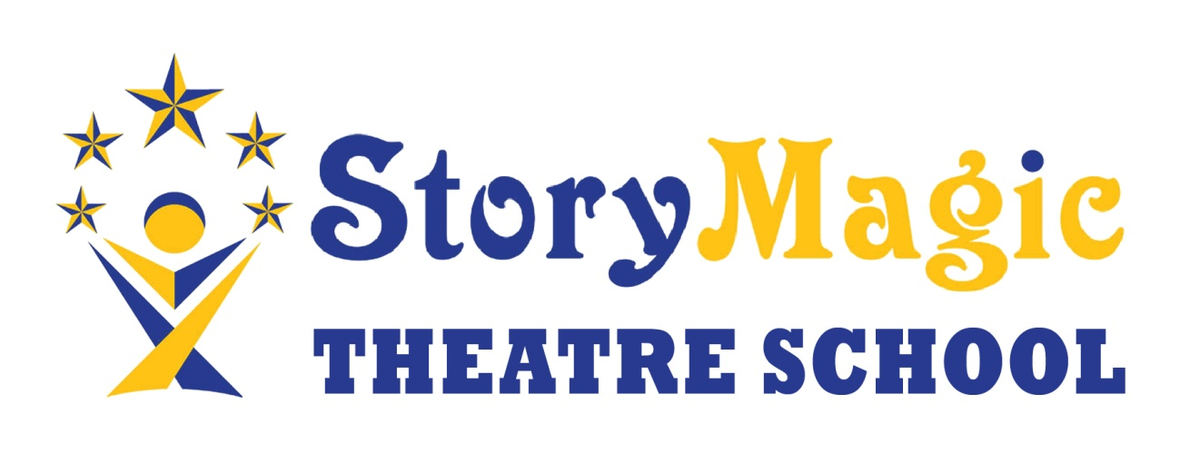
Safety measures for Bubbles of Fun! Theatre Week 2020
Numbers limited to 10-12 (dependant on siblings).
Children must attend the whole week.
Children should not attend any other setting during the period they are with us.
Families should avoid using public transport or lift sharing.
Children must wear a completely clean set of clothes each day.
Children must bring food and drinks they can open on their own.
There will be one adult in charge, the only other adult will come from the same household.
The adult in charge will undertake regular cleaning of surfaces, handles and mirrors. In particular in bathrooms.
Only siblings will be allowed to go the bathroom together (there are two cubicles)
Children will be allocated a table and standing space indoors. Only siblings will be allowed to share a space.
Regular handwashing and sanitising will be enforced.
Children with a cough or temperature will need to stay away.
Parents will not be allowed into the building.
Children must not arrive early. They will have the first 10 minutes to arrive.
Children should bring a back pack with coat, drinks, food, sun screen and hat and their own bottle of hand sanitiser.
Children, or children from the same household, will be allocated a set of resources for their own use only. There will be no sharing of resources.
As much as possible we will be outside.
When travelling to outside venues children will have a “measure” to carry to keep them apart from others.
There will not be an “opt out” facility for some activities. Children must be prepared to join in.
There will be no singing or shouting. Movement will be simple and not cause breathlessness.

